Academic Development Engagement Activity
I had academic advising with Kevin Parsons. This activity, I attended for advising and Academic Development to review my course roadmap. After advising, My advisor Kevin Parsons went over my course road map and modified & corrected classes. Also confirmed if classes were available during this semester and included a few elective classes that I could take if not available. This activity met my expectations, because it helped me in fixing and filling in my course roadmap class. Also got a link to the current year course catalog that helps in finding which electives classes are best for my planned major. https://catalog.charlotte.edu/preview_program.php?catoid=32&poid=8543
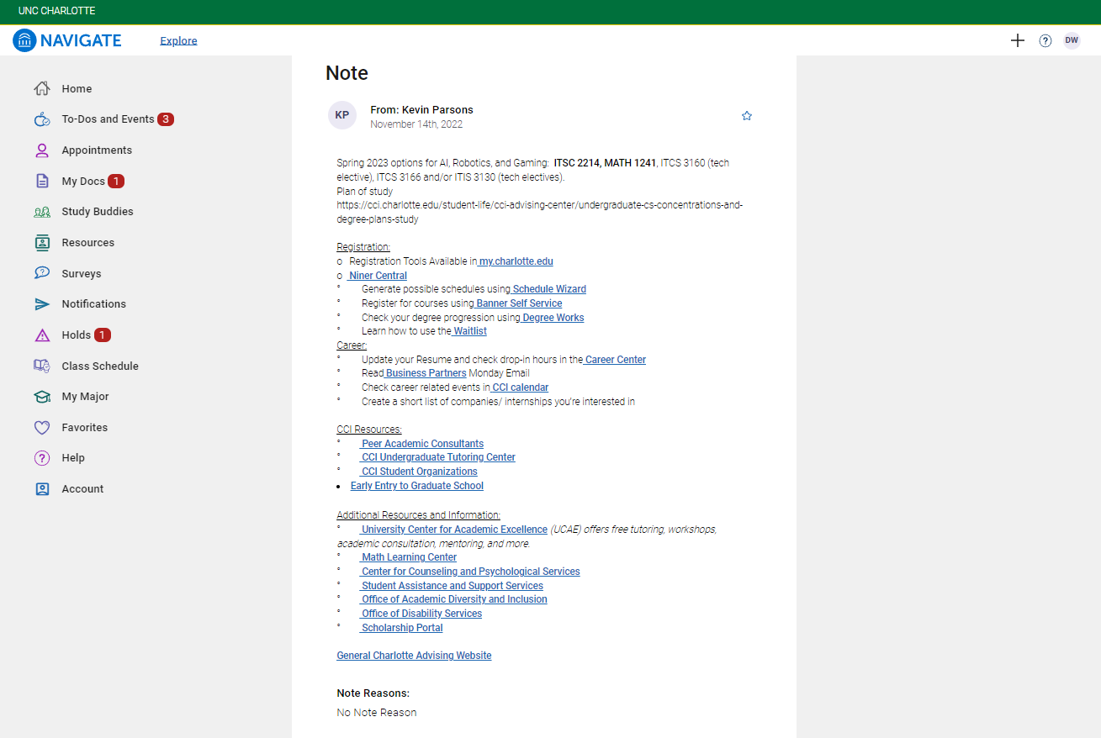

Old Course Roadmap
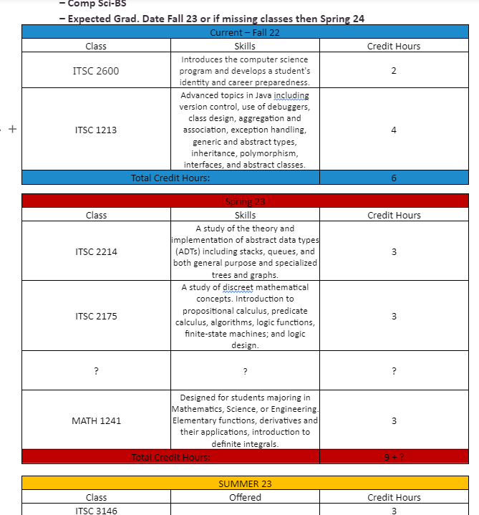
New Course Roadmap
